DIGITAL APPLICATIONS COMPUTER LAB (Venue B102)

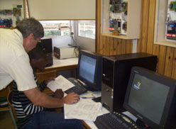

This laboratory with 30 stations are used to write application programmes for control system, digital system, Microsystems, and FPGA’s.

