PROJECTS LAB (Venue B 109)

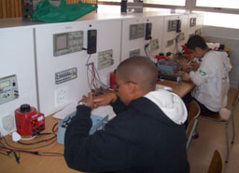

46 Work stations which contain all the tools students need to manufacture and construct projects. I.e. Power supply unit. Basic Hand Skills Projects 1.

